Web Basics – HTML5 Lab Book

# Lab 1: HTML Basics

|  |  |
| --- | --- |
| **Goals** | * Understand the process of creating an HTML page and viewing it in a browser window. * Learn to apply physical or logical character effects. * Learn to manage document spacing |
| **Time** | 45 minutes |

## : Create HTML Page

Create a web page to display the text ‘This is the first html page created’.

## Solution:

**Step 1:** Click the **Start** button**.** On the **Programs** menu, navigate to the **Accessories** submenu. Click **Notepad.**

**Step 2:** Write the below HTML program in Notepad.

<!DOCTYPE html>

<html>

<head>

<title>This is the first html page</title>

</head>

<body>

This is the first html page created

</body>

</html>

**Step 3:** Save the file with extension *.html*. Save it in the *lab1* directory as *firstpage.html*.

**Step 4:** From Internet Explorer, on the **File** menu, click **Open**. **Open** dialog box appears. Click

**Browse** to select the file you have just saved. Refer to the figure that follows.

**Step 5:** Once you have selected the file, click **OK** in the **Open** dialog box. Output appears as shown in the figure that follows.

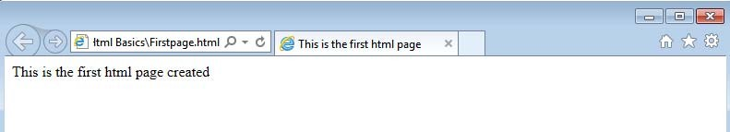

## Figure 1: First.html in a browser

## Example: MyFirstPage.html

<!DOCTYPE html>

<html>

<head>

<title>My First Page</title>

<meta [http‐equiv] [contents=n]>

<meta http‐equiv=refresh content=60>

<!‐‐‐will refresh the current document after every 60 seconds.‐‐>

<meta http‐equiv=refresh content=”20;url=c:/html/html34.htm”>

<‐‐will load secified file after 20 seconds. →

<base href=“c:/mydir/html/”>

<!‐‐ you to use shortcuts in your URLs if you must reference several files from the same location.‐‐>

</head>

<body> Hello World!! </body>

</html>

**Example 1: MyFirstPage.html**

**Output of the above HTML code is:**

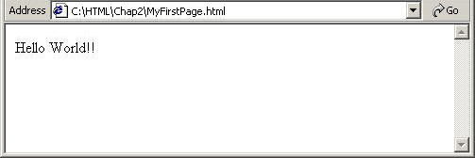

**Figure 2: MyFirstPage.html Output**

## Example: Headers.html

<!DOCTYPE html>

<html>

<head><title>This is the first html page</title>

<body>This is the first html page created

<h1>This is level 1 heading</h1>

<h2>This is level 2 heading</h2>

<h3>This is level 3 heading</h3>

</body>

</head></html>

**Example 2: Headers.html**

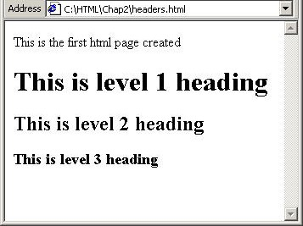

**Figure 3: Headers.html Output**

## Example: Address.html

<html>

<head>

<title>Address Example</title>

</head>

<body>

<font size="2">Your address:</font><br> Abc Xyz<br>

<address>b/102 royal palms,</address>

<address>off. s. v. road,</address>

<address>Andheri-West,</address><address>Mumbai.</address>

</body>

</html>

**Example 3: Address.html**

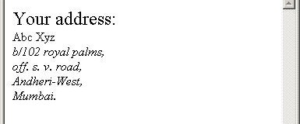

**Figure 4: Address.html Output**

## Example: PreFormattedText.html

|  |  |  |
| --- | --- | --- |
| SALESMAN | SALES | RANKING |
| TIM | $10,000 | 2<BR> |
| TOM | $ 5,000 | 5<BR> |
| TAMMY | $20,000 | 1<BR> |

<!DOCTYPE html>

<html>

<head><title>

PREFORMATTED TEXT EXAMPLE

</title></head>

<body>

<h3>GROSS SALE WITH PREFORMATTING</h3>

<hr>

<pre>

<b>GROSS SALES</b>

Each line has a carriage return after it.

</pre>

<h3>GROSS SALE WITHOUT PREFORMATTING</h3>

<p><hr>

<b>GROSS SALE<b>

**Example 4: PreFormattedText.html**

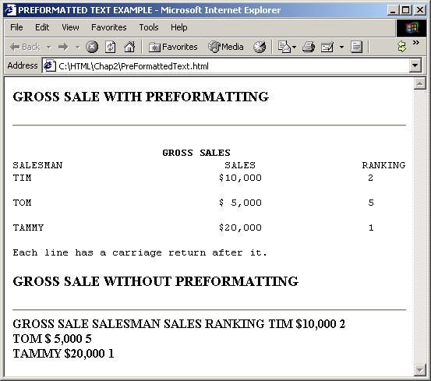

**Figure 5: PreFormattedText.html Output**

**Problem 1: Resume Creation <<To Do>>**

**Problem Statement:**

Create your resume page as per the format shown in the figure that follows.

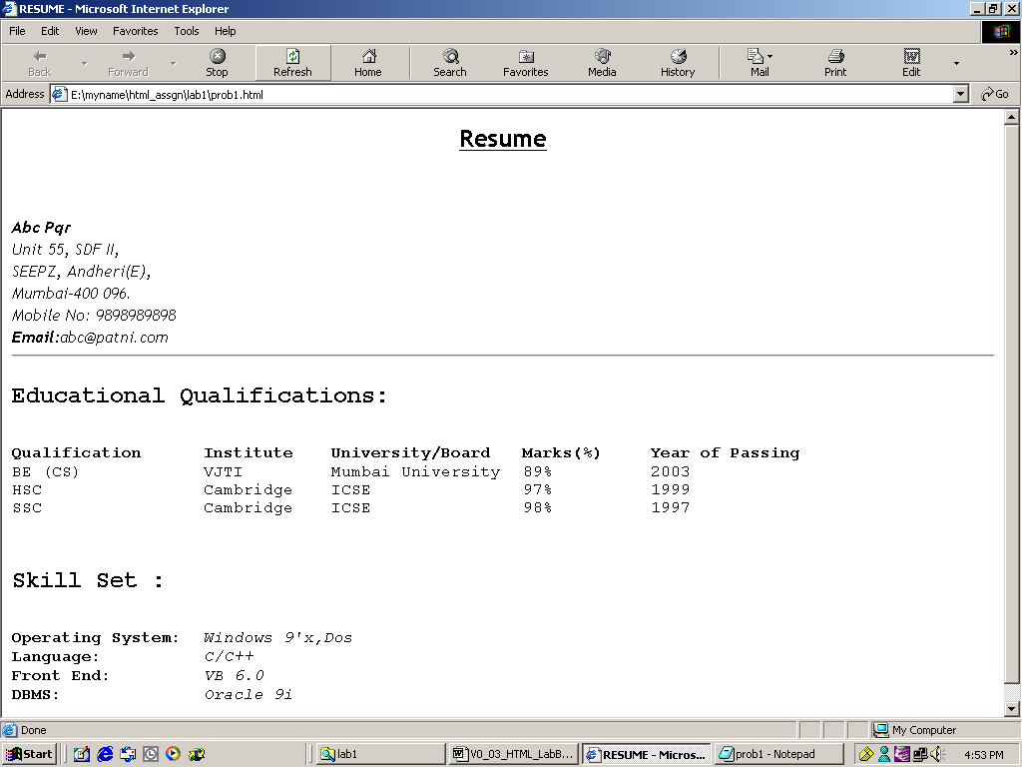

## Figure 6: Resume Page

**Solution:**

1. Open **Editor**. Type the code and save the file.
2. Use Heading 2 for the headings “Educational Qualifications” and “Skill Set”.
3. Use font size *3* for data pertaining to educational qualifications and skill set.
4. Display details against categories under *Skill Set* in *italics*.
5. Start the Internet Explorer. On the **File** menu, click **Open**. **File** open dialog box appears. Click the **Browse** button and select *prob2.html file*.
6. Check if the output is as per the requirement.

# Lab 2: Creating Tables

|  |  |
| --- | --- |
| **Goals** | At the end of this lab session you will understand:   * Attributes of a Table * Table Headers * Table Data * Table Formatting * Control Table Borders * Grouping of Columns |
| **Time** | 90 minutes |

## Problem 1: Fun with Food Problem Statement:

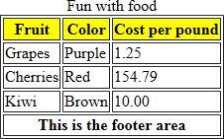Create a web page, which uses a table with columns *Fruit, Color* and *Cost per pound* as shown in the figure that follows.

## Figure 7: Fruits Table

## Problem 2: Table Heading << To Do>>

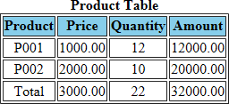**Problem Statement:** Create a html page*.* When this page is opened in a browser, it should appear as shown in the following figure

## Figure 8: Product table

**Note: Table heading - Background color is: navy and font color is: white.**

**Solution**

1. Open **Editor**. Type the code and save the file.
2. Open the page in browser
3. Check the page shown in the browser and verify that it is as per the requirement.

## Problem 3: Calendar <<To Do>> Problem Statement:

Design a web page to display a calendar for a month using html table.

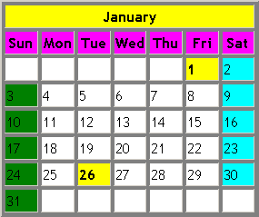

## Figure 9: Calendar

**Note:** Background colors to be used: For all the Sundays: green, for all the Saturdays: aqua, for 1, 26 Jan: yellow

**Solution**

1. Open **Notepad**. Type the code and save the file.
2. Open the page in browser.
3. Verify that the output is as per requirements.

# Lab 3: Working with Lists

|  |  |
| --- | --- |
| **Goals** | At the end of this lab session you will be able to use following types of lists:   * Numbered List * Bulleted List * Directory List * Glossary List |
| **Time** | 30 minutes |

## Problem 1: Types of Lists Problem Statement:

Design a web page as shown below

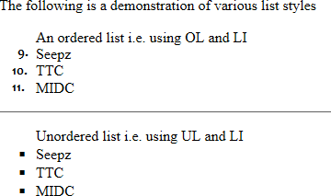

## Figure 10: List

**Solution**

Step 1: Write the following code in Notepad and save.

<!DOCTYPE html>

<html>

<head>

<title>Working with Lists</title>

</head>

<body>

<p>The following is a demonstration of various list styles

<ol start="3">

An ordered list i.e. using OL and LI

<li>Seepz

<li value="10">TTC

<li>MIDC

</ol>

<hr>

<ul style="list-style-type: square"> Unordered list i.e. using UL and LI

<li>Seepz

<li>TTC

<li>MIDC

</ul>

</body>

</html>

## Example 6: Types of Lists

**Step 2:** Check the page shown in the browser and verify that it is as per the requirement.

## Problem 2: Subjects <<To Do>>

Create a web page to display a list as shown in the figure that follows.

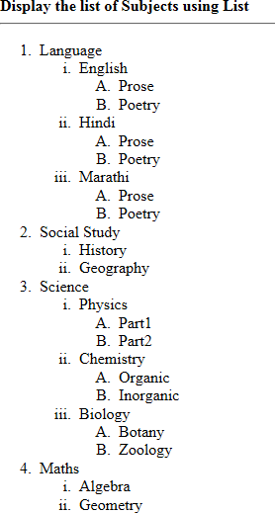

## Figure 11: Subject list

**Solution**

1. Open **Notepad**. Type the code and save the file.
2. Open the page in browser.
3. Check the page shown in the browser and verify that it is as per the requirement.

# Lab 4: Working with Links

|  |  |
| --- | --- |
| **Goals** | At the end of this lab session you will be able to:   * Create links to web documents. * Create links to email. * Create hyperlinks for lists and table data. * Provide target for hyperlink. |
| **Time** | 30 minutes |

## Problem 1: Welcome to Big Company

**Problem Statement:**

Design a simple home page for a company with a heading and 3 links – About, Products, Contact as given in the figure below.

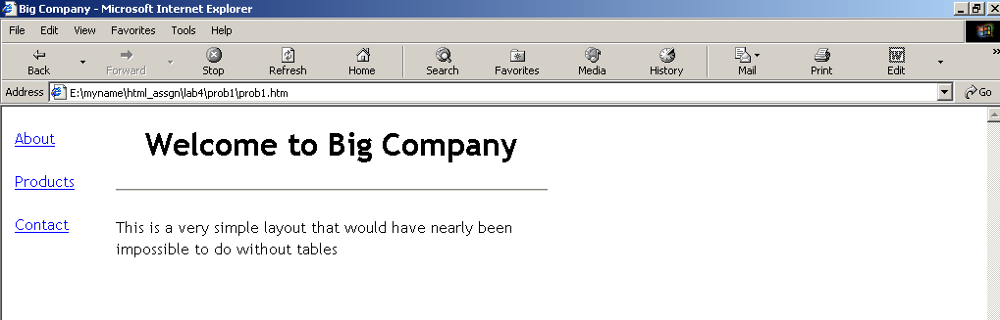

## Figure 12: Big Company home page

When you click the “About” hyperlink, following page should be displayed.



## Figure 13: About

When you click the **Back** button on the browser toolbar, they should be redirected to the page

*prob1.html*. Click the “Products” hyperlink to reach the following page:

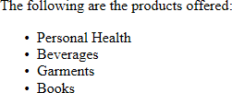

## Figure 14: Products

When you click the **Back** button on the browser toolbar, they are redirected to page *prob1.html*. Click the “Contact” hyperlink. It opens Outlook Express and the e-mail address given in the *To* field, which is [lnd.in@capgemini.com](mailto:lnd.in@capgemini.com) in the following illustration, is displayed in the New message window. This email address is specified in the *mailto* attribute.

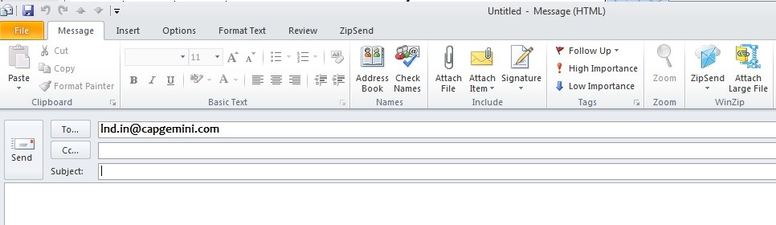

## Figure 15: Contact

**Solution**

**Step 1:** Write the following code in **Notepad** and save the file*.*

<!DOCTYPE html>

<html>

<head>

<title>Big Company</title>

</head>

<body>

The Big company was founded in 1956.

</body>

</html>

## Example 7: Big Company

**Step 2:** Write the following code in **Notepad** and save it as the file.

<!DOCTYPE html>

<html>

<head>

<title>Products</title>

</head>

<body>

The following are the products offered :

<ul>

<li>Personal Health </li>

<li>Beverages </li>

<li>Garments </li>

<li>Books </li>

</ul>

</body>

</html>

## Example 8: Products

**Step 3:** Write the following code in **Notepad** and save the file.

<!DOCTYPE html>

<html>

<body>

<table>

<tr>

<td>

<a href="about.htm">About</a><br><br>

<a href="products.htm">Products</a><br><br>

<a [href="mailto:lnd@cap](mailto:lnd@capgemini.com)ge[mini.co](mailto:lnd@capgemini.com)m">Contact</a><br><br>

</td>

<td>

<h1>Welcome to Big Company</h1>

<hr>

<p>This is a very simple layout that would have nearly been impossible to do without tables</p>

</td>

<td><br></td>

</tr>

</table>

</body>

</html>

## Example 9: Welcome to Big Company

**Step 4:** Start the Internet Explorer. On the **File** menu, click **Open**. **Open** dialog box appears. Click the **Browse** button and open the page with links file. Verify if the links on the page are working as per the requirement.

## Problem 2: Employee Details <<To Do>>

**Problem Statement:**

Design a simple home page for a company to display employee details as given below.

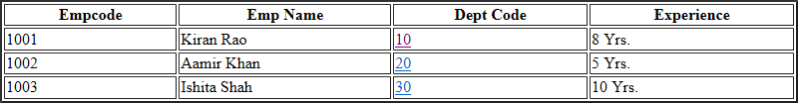

## Figure 16: EmployeeDetails

When you click the department code “10” hyperlink, page with following content should be displayed.

This is Sales department located at Mumbai...

## Figure 17: Sales Department

When you click the department code “20” hyperlink, page with following content should be displayed.

This is training department located at Pune...

## Figure 18: Training Department

When you click the department code “30” hyperlink, page with following content should be displayed.

This is accounts department located at Chennai...

## Figure 19: Accounts Department

# Lab 5: Image Handling

|  |  |
| --- | --- |
| **Goals** | At the end of this lab session you will be able to:   * Understand the use of inline images. * Attributes of an inline image. * Text and image aligning. * Use of an image as a hyperlink. |
| **Time** | 30 minutes |

**Problem 1: Images with Clickable Areas <<To do>> Problem Statement:**

Create a web page with some images as shown in following figure:

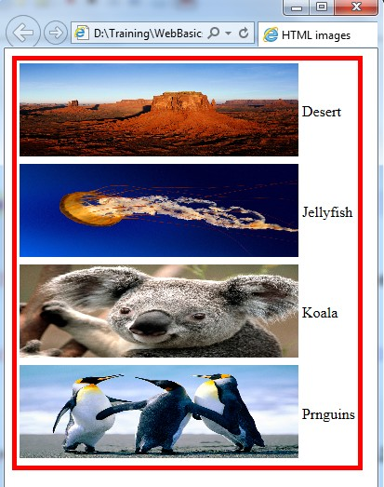

## Figure 20 : Images

# Lab 6: HTML Forms for User Input

|  |  |
| --- | --- |
| **Goals** | At the end of this lab session you will be able to:   * Understand the role of forms in web pages. * Understand various HTML elements used in forms. * Develop HTML forms in web pages. |
| **Time** | 45 minutes |

## Problem 1: Form

**Problem Statement:**

Design a web page *prob1.html* in the directory *lab7*. When *prob1.html* is opened in the browser, the page is displayed as shown in the figure that follows.

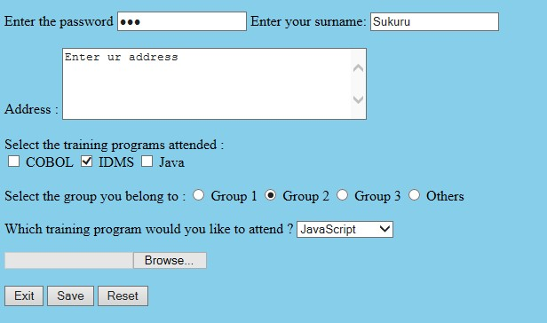

## Figure 244: Forms

**Solution**

**Step 1:** Write the following code in **Notepad** and save it as *lab6\prob1.html*.

<!DOCTYPE html>

<html>

<head>

<title>Form Methods</title>

</head>

<body style="background-color:skyblue">

<form action[="mailto:lnd.in@capgemin](mailto:lnd.in@capgemini.com)i.[com"](mailto:lnd.in@capgemini.com) name="ab" method="post" enctype="multipart/form-data">

<p>

Enter the password

<input type="password"name="USERNAME" size="20" value="abc" tabindex="3">

<input type="hidden" name="coname" value="PCS"> Enter your surname:

<input type="text" name="surname" SIZE="20" readonly value="Sukuru" tabindex="2" maxlength="30"> <br> <br>

Address :

<textarea name="addr" Rows="5" cols="40" tabindex="0" accesskey="A">Enter ur address </textarea>

<br> <br> Select the training programs attended : <br>

<input type="checkbox" name="s-cobol"> COBOL

<input type="checkbox" name="s-idms" checked> IDMS

<input type="checkbox" name="s-java"> Java <br> <br> Select the group you belong to :

<input type="radio" name="s-grp" value="grp1"> Group 1

<input type="radio" name="s-grp" value="grp2" checked> Group 2

<input type="radio" name="s-grp" value="grp3"> Group 3

<input type="radio" name="s-grp" value="oth"> Others <BR> <BR> Which training program would you like to attend ?

<select name="pref">

<option value="JS">JavaScript </option>

<option value="CORBA">CORBA </option>

<option value="VB6">Visual Basic 6 </option>

</select>

</p>

<input type="file" name="fnm"> <br><br>

<input type="button" name="but" value="Exit">

<input type="Submit" Value="Save" name="s-but">

<input type="reset" Value="Reset">

</form>

</body>

</html>

## Example 14: Forms

**Step 2: Open** *prob1.html* in the browser and verify if the form is displayed as per the requirement.

## Problem 2: Employee Details <<To Do>> Problem Statement:

Design a web page *prob2.html* to accept the following employee details:

* + Employee Name (Max 20 characters).
  + Employee Code (Max 4 characters).
  + Department (Use radio buttons).
  + Date of Join (Use the format dd/mm/yyyy).
  + Address.
  + Training programs attended (Use check boxes).
  + Training programs need to attend (Use select box).
  + Send the information at [empinfo@capgemini.com.](mailto:empinfo@capgemini.com)

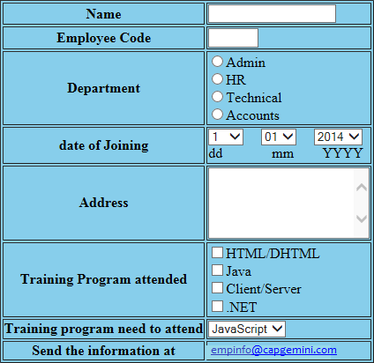

## Figure 255: Employee Details

**Solution**

1. Open **Editor**. Type the code and save the file as lab7\prob2.html.
2. Open the page in the browser.
3. Verify if the output is as per the figure.

# Lab 7: New Form Elements

|  |  |
| --- | --- |
| **Goals** | At the end of this lab session, you will be able to:   * Develop web pages using HTML5 enhanced form elements |
| **Time** | 120 minutes |

## Problem 1: Form Problem Statement:

Design a web page *prob1.html* in the directory *lab8*. When *prob1.html* is opened in the browser, the page is displayed as shown in the below figure

## Solution

**Step 1:** Write the following code in **Notepad** and save it as *lab8\prob1.html*.

<! DOCTYPE html>

<html>

<head>

<meta

scalable=no" />

name="viewport"

content="height=device-height,width=device-width,user-

<meta charset="UTF-8">

<title>New Form Elements</title>

</head>

<body>

<form name="Formelements" action="index2.jsp">

<table>

<tr>

<td><label for="demo">Placeholder : </label></td>

<td><input id ="demo" name="demo" placeholder="Enter Numbers Only" /></td>

</tr>

<tr>

<td><label for="nameauto">Autofocus : </label></td>

<td><input id ="nameauto" name="nameauto" type="text" autofocus/></td>

</tr>

<tr>

<td><label for="range">Range : </label></td>

<td><input id="range" name="range" type="range" min="0" max="50" value="10"

/><td>

</tr>

<tr>

<td><label for="search">Search : </label></td>

<td><input id="search" name="search" type="search" placeholder="Search..."

/><td>

</tr>

<tr>

<td><label for="date">Date : </label></td>

<td>

<input id="date" name="date" type="date" min="2010-08-14" max="2014-08-14" value=""/></td>

</tr>

<tr>

<td><label for="date">Week : </label></td>

<td><input id="date" name="date" type="week" value=""/></td>

</tr>

<tr>

<td><label for="date">Month : </label></td>

<td><input id="date" name="date" type="month" value=""/></td>

</tr>

<tr>

<td><label for="date">Time : </label></td>

<td><input id="date" name="date" type="time" value=""/></td>

</tr>

<tr>

<td><label for="number">Number : </label></td>

<td>

<input id="number" name="number" type="number" step="1" min="-5" max="10" value="0" />

<td>

</tr>

<tr>

<td><label for="required">Required : </label></td>

<td><input id="required" name="user" type="text" required /></td>

</tr>

<tr>

<td><label for="email">Email:</label></td>

<td><input id="email" name="email" type="email" required/></td>

</tr>

<tr>

<td><label for="color">Color : </label></td>

<td><input id="color" name="color" type="color" placeholder="e.g. #bbbbbb"

/><td>

</tr>

<tr>

<td><label for="country_name">Country : </label></td>

<td><input id="country_name" name="country_name" type="text" list="country"

/></td>

<td><datalist id="country">

<option value="Afghanistan">

<option value="Albania">

<option value="Algeria">

<option value="Andorra">

<option value="Angola">

<option value="Car">

<option value="Cat">

<option value="City">

<option value="Cup">

<option value="Clip">

</datalist></td>

</tr>

<tr><td colspan="2"><audio controls >

<source src= "god.mp3" type="audio/mpeg" />

<source src= "1vs0_JuniorGroove.ogg" type="audio/ogg"/>

</audio></td></tr>

<!-- audio code works on Firefox and opera .ogg format only -->

<tr>

<td colspan="2"><video [src="http://upload.wi](http://upload.wikimedia.org/wikipedia/commons/7/79/Big_Buck_Bunny_small.ogv)kime[dia.org/wikipedia/commons/7](http://upload.wikimedia.org/wikipedia/commons/7/79/Big_Buck_Bunny_small.ogv)/[79/Big_Buck_Bunny_small.ogv"](http://upload.wikimedia.org/wikipedia/commons/7/79/Big_Buck_Bunny_small.ogv) controls width="300" height="250">

</video></td></tr>

<!-- Video code works only on Firefox. .ogg format. various ogg file extension are

.ogx, .ogv, .oga, .spx. -->

</table>

<table>

<tr>

<td align="right"><button type="submit" name="submit" value="Submit">Submit</button></td>

<td align="left"><button type="reset" name="reset" value="reset">Reset</button></td>

</tr>

</table>

</form>

</body>

</html>

## Example 155: Code for New Form Elements

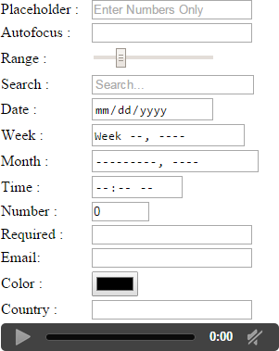

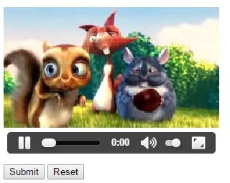

**Figure 266: New Form Elements**

## Problem 2: Candidate Details <<To Do>>

**Problem Statement:**

Design a web page StudentInfoForm.html to accept the following student details:

1. Name (Accept only characters , Max 15 characters )
2. Password (Max 15 characters)
3. Phone number(Accept 10 digits)
4. Gender (Make use of radio button)
5. Date of Birth (Make use of date field and date of birth should not be greater than current date)
6. Email (Accept valid Email)
7. Highest Qualification (Make use of datalist to populate data like B.Tech, M.Tech, MBA, MCA, MSc, MA, BSC..)
8. Courses interested in (Make use of check box)
9. Comments to mention regarding Degree / External Certificates (Make use of textarea)
10. Uploading Degree / External certificates (Make use of file input type)
11. Use Placeholders to describe the type of input.
12. All fields marked (*) are mandatory

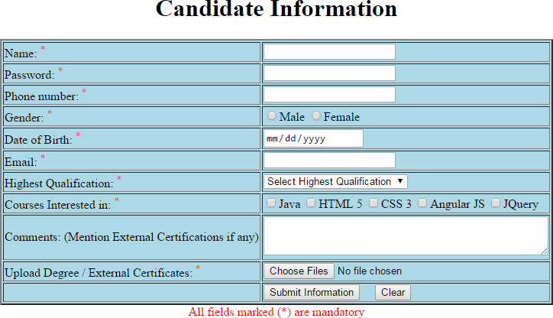

## Figure 277: Candidate Details

**Solution**

1. Open **Editor**. Type the code and save the file as lab7\prob2.html.
2. Open the page in the browser.
3. Verify if the output is as per the figure